**Aim:** Demonstration of Logistics Regression.

**Theory**: Explain Logistic Regression in detail.

**Code:**

X<-read.csv("C:/Users/Admin/Documents/SampleStudentData.csv")

> X

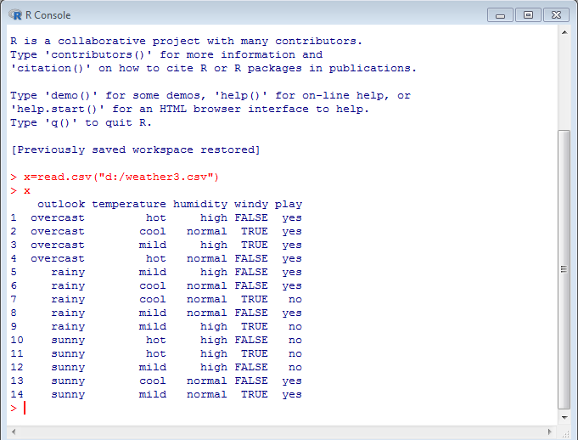

**PRINTING THE DATASET**

>x$humidity=ifelse(test=x$humidity=="high",yes=1,no=0)

>x

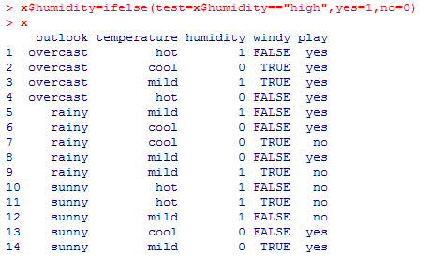**>x$play=ifelse(test=x$play=="yes",yes=1,no=0)**

**>x**

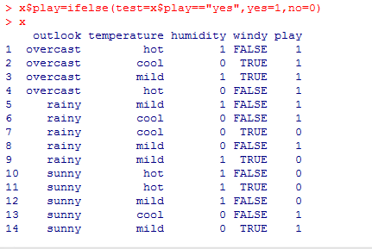**>x$windy=ifelse(test=x$windy=="FALSE",yes=0,no=1)**

**>x**

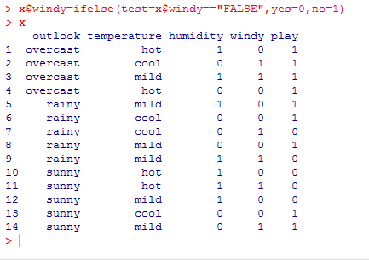

**PARTIONING DATASET**

> s=sample(nrow(x),.7*nrow(x))

>x_tr=x[s,]

>x_test=x[-s,]

>nrow(x)

>nrow(x_tr)

>nrow(x_test)

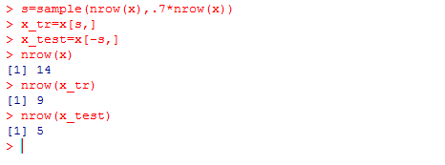

**DATA MODELING**

>lmod=glm(play~windy,data=x_tr,family=binomial,control=list(maxit=100))

>lmod

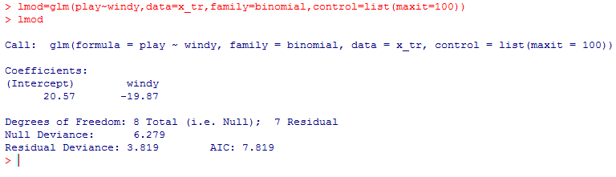

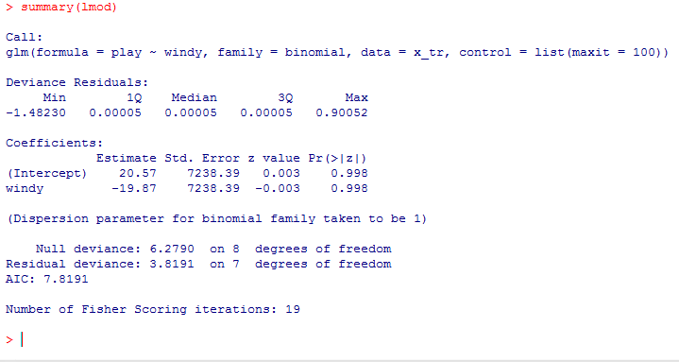

>lmod=glm(play~humidity,data=x_tr,family=binomial,control=list(maxit=100))

>summary(lmod)

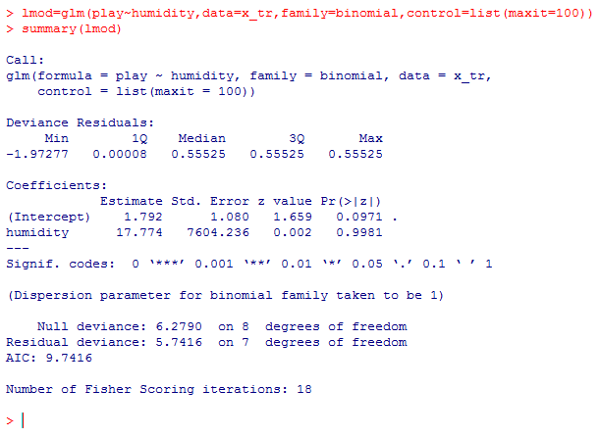>lmod=glm(play~temperature,data=x_tr,family=binomial,control=list(maxit=100))

>summary(lmod)

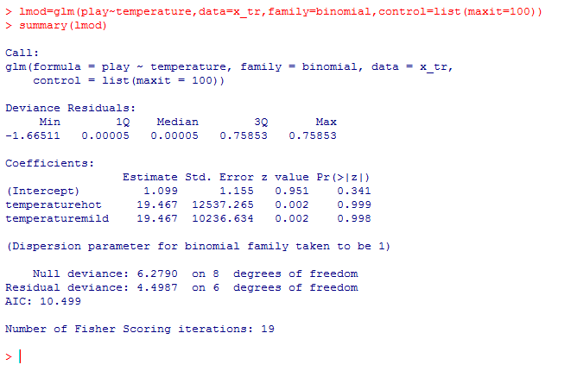

**#PREDICTION:**

> p=predict(lmod,x_test,type="response")

>p

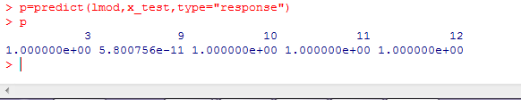

**(2) SECOND DATA SET:**

**#IMPORT THE DATA**

>x2=read.csv("D:/grade_logit.csv")

>x2

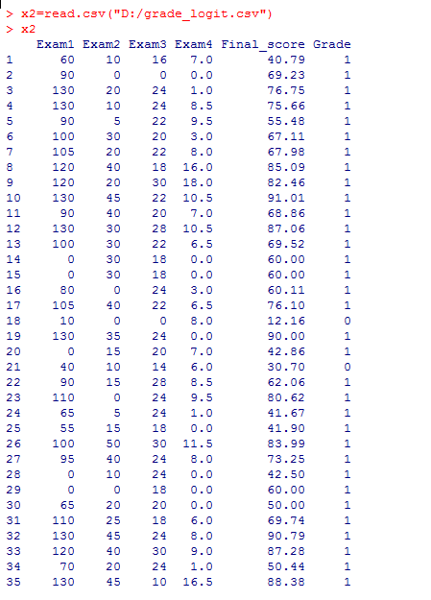

> lmod2=glm(Grade~Exam1,data=x2_train,family=binomial,control=list(maxit=100))

>summary(lmod2)

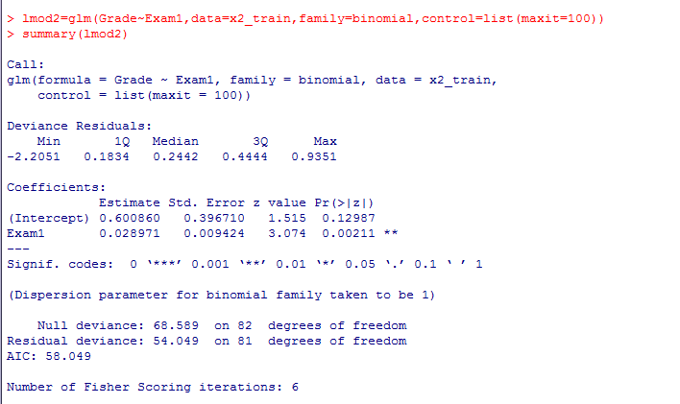

**Prediction data 1’s and 0’s form**

>prediction=ifelse(p>.5,1,0)

>prediction

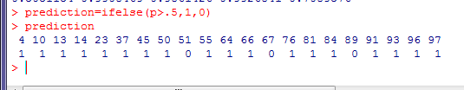 **PREDICTION MATRIX**

>table(x2_test$Grade,prediction)

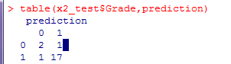

> x2_test

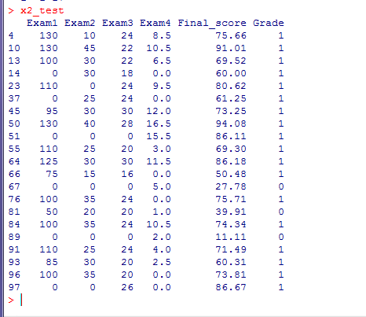

**#actuals predicted**

>ac_pr<- data.frame(cbind(actuals=x2_test$Grade, predicteds=prediction))

>ac_pr

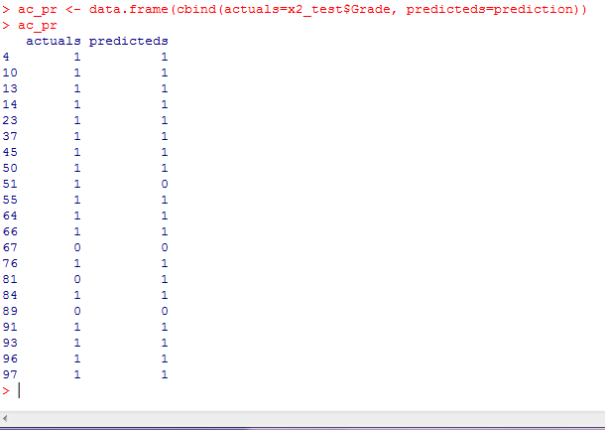

**>vif(lmod2) // variable influence factor**

